**Front-End UI/UX Mini Project**

**Project Submission Template**

Music Band Website- Crimson Heart

**Submitted By:**

* Adithya Raj
* 2460310
* adithya.raj@btech.christuniversity.in
* Alen K Reji
* 2460319
* alen.k@btech.christuniversity.in
* Chris Jossy Baptist
* 2460348
* chris.jossy@btech.christuniversity.in

**Course:** UI/UX Design Fundamentals

**Instructor Name:** Dhiraj Alate

**Institution:** Christ University

**Date of Submission:** 12-08-2025

**2. Abstract**

This project is about making a website for our fictional music band called "Crimson Heart" using just HTML and CSS. The main goal was to create a cool-looking website that works well on phones, tablets, and computers. I included pages for the band info, their songs, upcoming concerts, and a way for fans to contact them. The website has a dark theme with red colours to match the band name. It was challenging but fun to make everything look good without using any JavaScript.

**3. Objectives**

* Make a website that looks professional and matches the band's rock/alternative style
* Create a responsive design that works on all devices using only HTML and CSS
* Use proper HTML5 tags that I learned in class
* Style everything with CSS to make it look consistent and appealing
* Make sure the website is easy to navigate and looks good on mobile phones
* Practice what we learned about user-friendly design

**4. Scope of the Project**

**What We included:**

* Only front-end stuff - no backend programming needed for this assignment
* No JavaScript (we haven't learned that yet)
* Made it work on desktop, tablet, and mobile screens
* Used only HTML and CSS code that I wrote myself
* Added sections for: Home page, About the band, Music albums, Concert dates, Photo gallery, and Contact info

**What We didn't include:**

* Can't actually play music (just showed album covers and info)
* Contact form doesn't actually send emails
* Social media buttons don't really work
* No database to store information

**5. Tools & Technologies Used**

| **Tool/Technology** | **What I used it for** |
| --- | --- |
| HTML5 | To structure all the content and text |
| CSS3 | To make everything look good and responsive |
| VS Code | The code editor we use in class |
| Chrome DevTools | To test how it looks on different screen sizes |

**6. HTML Structure Overview**

I used the HTML tags we learned in class like <header>, <nav>, <main>, <section>, and <footer> to organize everything properly. The website has different sections:

* A big header with the band name and navigation menu
* About section talking about the band members
* Music section showing their albums
* Events section with concert dates
* A photo gallery
* Footer with contact information

I made a navigation menu using <ul> and <li> tags with links that jump to different parts of the page when you click them.

**7. CSS Styling Strategy**

I put all my CSS in a separate file called "styles.css" to keep things organized. I learned to use:

* **Flexbox** for arranging items in rows and columns (this was tricky at first!)
* **CSS Grid** for the photo gallery layout
* **Media queries** to make it look different on phones vs computers
* **CSS variables** to store the colours so I could use them everywhere
* **Hover effects** to make buttons and images do cool things when you point at them
* I started designing for mobile first, then made it bigger for desktop

**8. Key Features**

| **Feature** | **What it does** |
| --- | --- |
| Mobile-friendly design | Automatically adjusts to fit phone screens |
| Sticky navigation | Menu stays at the top when you scroll down |
| Band member cards | Shows pictures and info about each band member |
| Album showcase | Displays album covers in a nice grid |
| Concert schedule | Shows upcoming shows in a table |
| Photo gallery | Grid of band photos with hover effects |
| Dark theme | Black background with red accents to look rock-ish |

**9. Challenges Faced & Solutions**

| **Problem I had** | **How I fixed it** |
| --- | --- |
| Things looked messy on small screens | Used media queries to stack everything vertically on phones |
| Couldn't get items to line up properly | Switched from using floats to flexbox (much easier!) |
| Text was too small on mobile | Used rem units instead of pixels so text scales better |
| Navigation menu took up too much space on phones | Made it collapse into a simple menu (CSS only) |
| Images were different sizes and looked weird | Set consistent heights and used object-fit property |

**10. Outcome**

I'm pretty happy with how it turned out! The website looks professional and actually works like a real band website. Everything I planned to include is there and working. I learned a lot about making websites responsive - it's harder than I thought but really satisfying when it works. The hardest part was getting the layout to look good on both phones and computers, but I figured it out eventually.

**11. Future Enhancements**

If I keep working on this project, I'd like to add:

* **JavaScript stuff** like:
  + Making the contact form actually work
  + Adding music players so you can listen to songs
  + Making a slideshow for the photos
  + Adding smooth scrolling effects
* **More features:**
  + A way to buy band merchandise
  + Newsletter signup
  + Maybe a fan forum or comments section
* **Better performance:** Making images load faster and the site run smoother

**12. Sample Code**

**HTML - Main Header Section**

<header class="hero">

<nav class="navbar">

<div class="logo">

<h1>Crimson Heart</h1>

</div>

<ul class="nav-menu">

<li><a href="#home">Home</a></li>

<li><a href="#about">About</a></li>

<li><a href="#music">Music</a></li>

<li><a href="#events">Events</a></li>

<li><a href="#contact">Contact</a></li>

</ul>

</nav>

<div class="hero-text">

<h2>Welcome to Crimson Heart</h2>

<p>Rock music that speaks to your soul</p>

<button class="hero-button">Check Out Our Music</button>

</div>

</header>

**CSS - Making the Album Grid Look Good**

/* These are my main colors */

:root {

--red-color: #8B0000;

--dark-bg: #2C2C2C;

--white-text: #FFFFFF;

}

.album-grid {

display: grid;

grid-template-columns: repeat(auto-fit, minmax(200px, 1fr));

gap: 20px;

padding: 40px 0;

}

.album-card {

background: var(--dark-bg);

border-radius: 8px;

padding: 20px;

text-align: center;

transition: transform 0.3s ease;

}

.album-card:hover {

transform: translateY(-5px);

box-shadow: 0 8px 16px rgba(139, 0, 0, 0.4);

}

**CSS - Mobile Responsive Design**

/* This makes it work on phones */

@media (max-width: 768px) {

.nav-menu {

flex-direction: column;

background: var(--dark-bg);

position: absolute;

top: 100%;

width: 100%;

}

.hero-text h2 {

font-size: 1.8rem;

}

.album-grid {

grid-template-columns: 1fr 1fr;

gap: 15px;

}

}

**13. Screenshots of Final Output**

**Desktop Homepage**

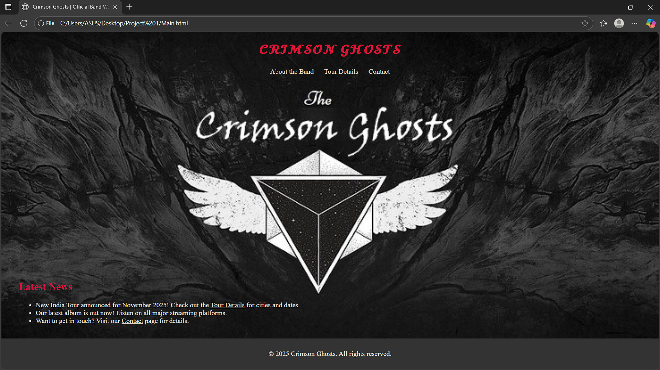

**About Band Members Section**

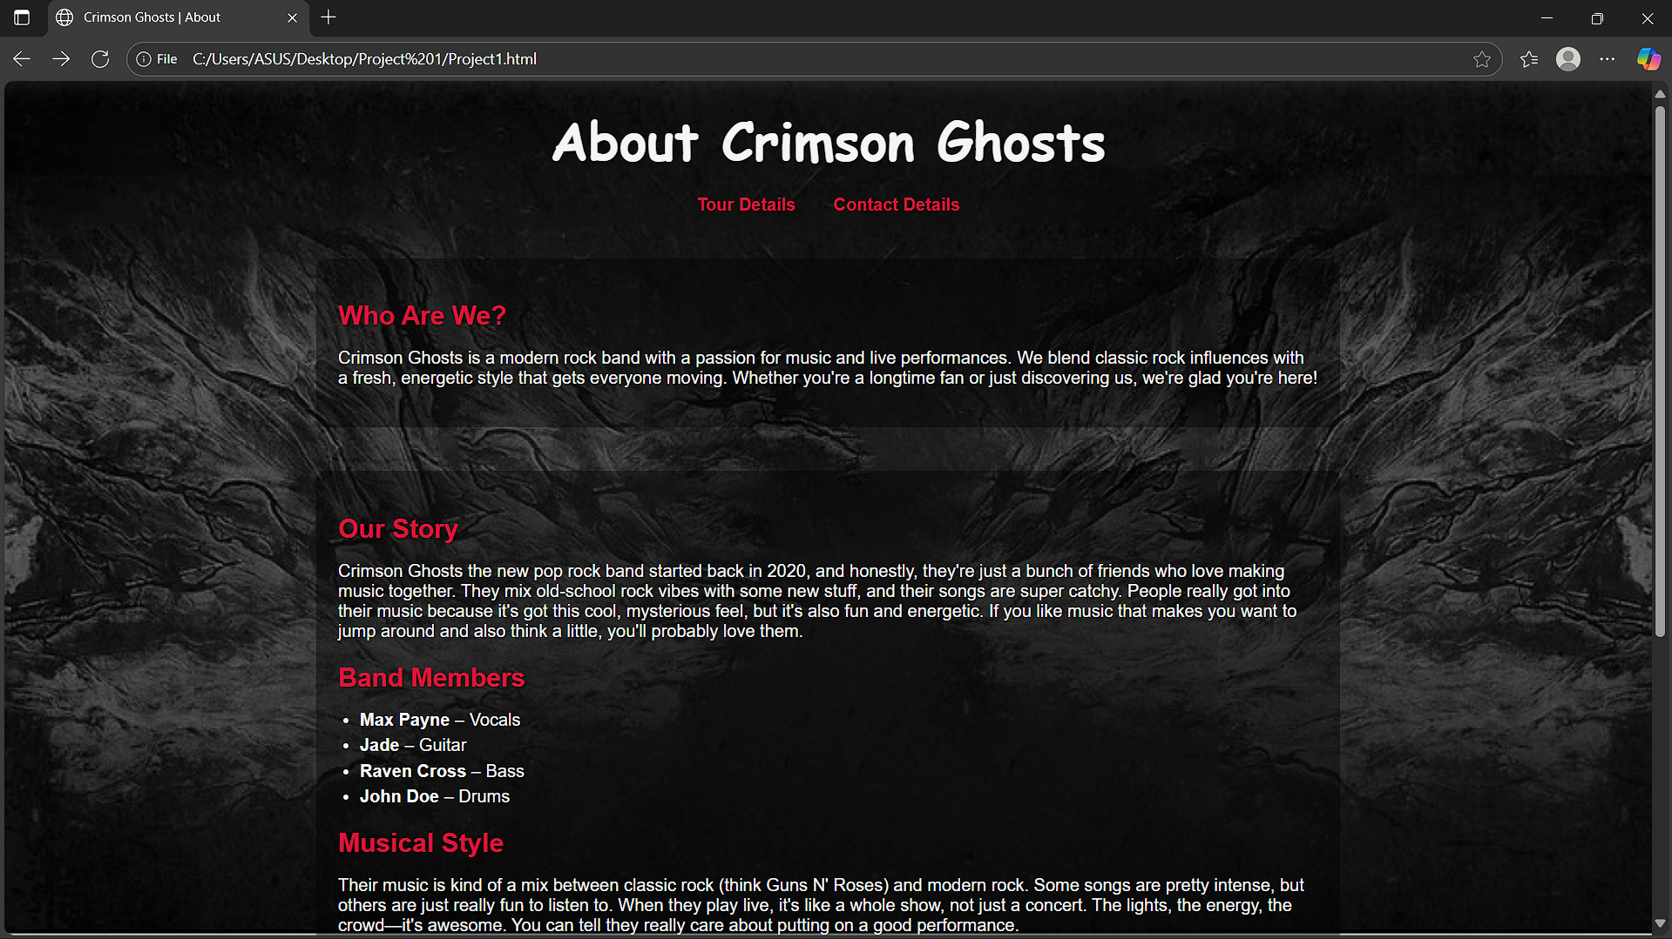

**Tour Details Page**

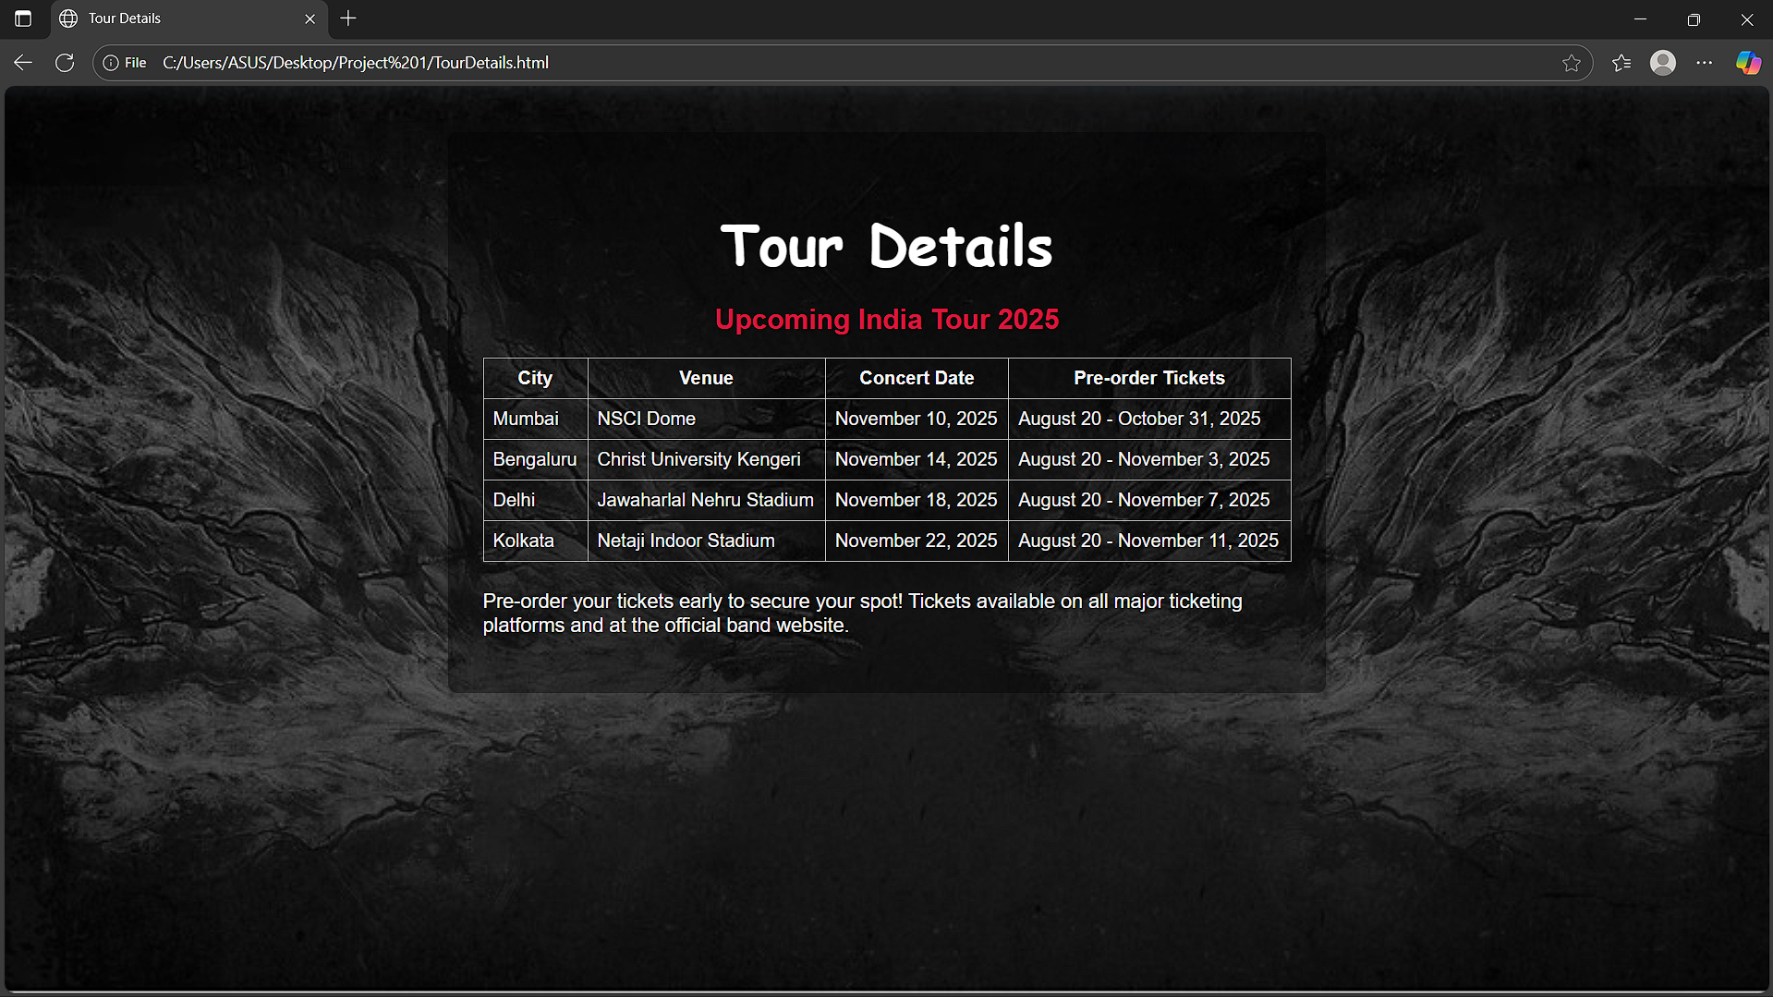

**Contact page**

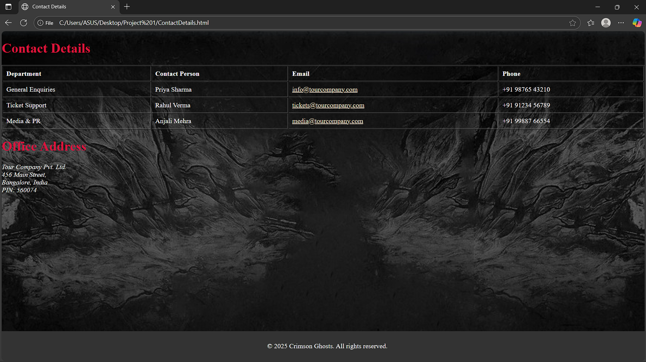

**14. Conclusion**

This project was a great learning experience for me. Building the Crimson Heart website taught me so much about HTML and CSS that I didn't know before. The hardest parts were figuring out flexbox and making everything look good on different screen sizes, but once I got the hang of it, it became really fun.

I'm proud of how the website turned out - it actually looks like something a real band might use. The dark theme with red accents gives it a rock band vibe, and everything is organized in a way that makes sense for visitors. I also learned that responsive design is super important since most people probably look at websites on their phones.

This project made me realize how much work goes into making websites, but also how creative you can be with just HTML and CSS. I'm excited to learn JavaScript next semester so I can make the interactive parts actually work!

**15. References**

* **L&T LMS:** https://learn.lntedutech.com/Landing/MyCourse
* **W3Schools:** Used this a lot to look up CSS properties I forgot
* **YouTube tutorials:** Watched a few videos about flexbox when I got stuck
* **MDN Web Docs:** For checking if certain CSS features work in different browsers